**Curriculum Vitae (C.V)**

**I. General information:**

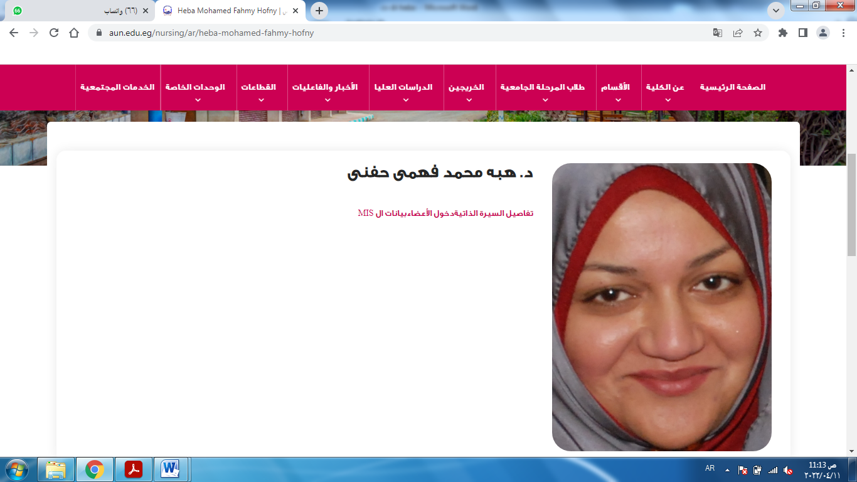

**Name:-**  Heba Mohamed Fahmy

**Birth date:-**  1/7/1983**.**  
**Civil status:-** Married.  
**Present position:-** Assistant professor.  
**Address:-** Assiut University.  
**Tel. No. :-**  01013065870

**E-mail :** hebafahmy53@yahoo.com.

**Academic email:-** [hebafahmy@aun.edu.eg](mailto:hebafahmy@aun.edu.eg).

**Educational qualification:-**- **II**

|  |  |  |
| --- | --- | --- |
| **Institution** | **Years** | **Scientific degree** |
| Assiut university | 2004 | Baccalaureate |
| Assiut university | 2011 | Master |
| Assiut university | 2016 | Decorate |
|  |  |  |

**III-Hierarchy academic career:-**

|  |  |  |
| --- | --- | --- |
| **Institution** | **Years** | **Occupation** |
| Assiut university | 2005 | Demonstrator |
| Assiut university | 2011 | Assistant Lecturer |
| Assiut university | 2016 | Lecturer |
| Assiut university | 2021 | Assistant professor |

**IV. Receiving training program of quality about:**  
1- Methods of Scientific Research  
2- Scientific Publishing  
3- English language  
4- The system of credit hours.

**V-Activities in the field of quality management systems / education**  
**development projects:**  
1. Workshop on exams systems and students evaluation  
2. Workshop on OSCE   
3. Participate in course specification  
**VI-Activities that are related to the educational process and**  
community **service.**  
1. Visits to the elderly club and give guidance for the elderly to prevent  
disease  
2. Seminars for the elderly (elderly nutrition- the immune system of the  
elderly- Alzheimer’s disease).  
3. Provide guidance and health education for the elderly in the Outpatient  
and Department of Internal Medicine in University Hospital.